1)

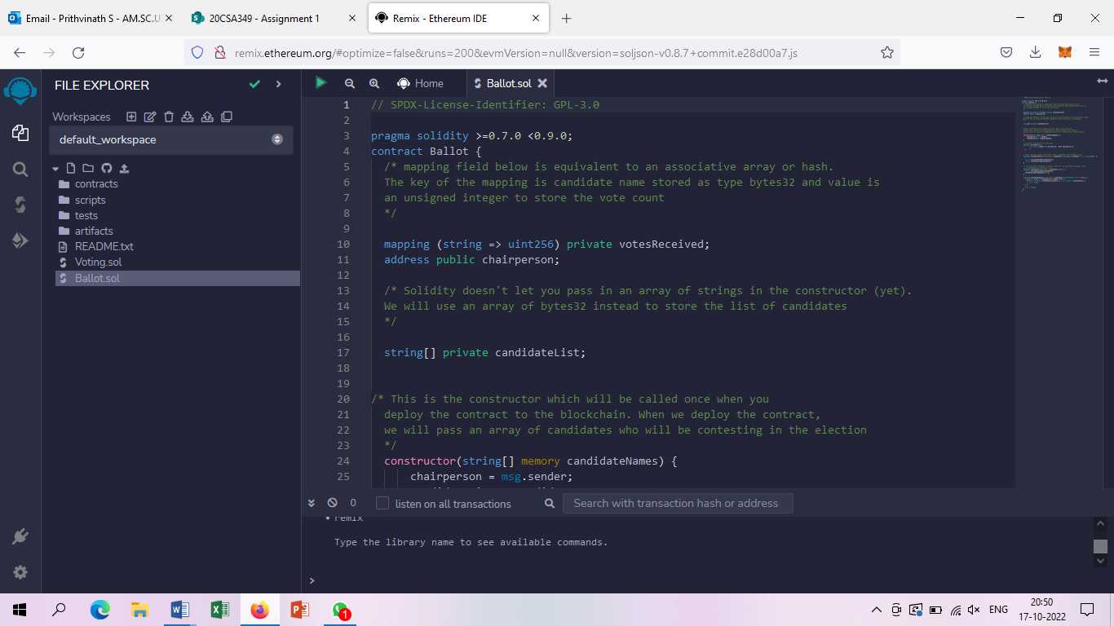

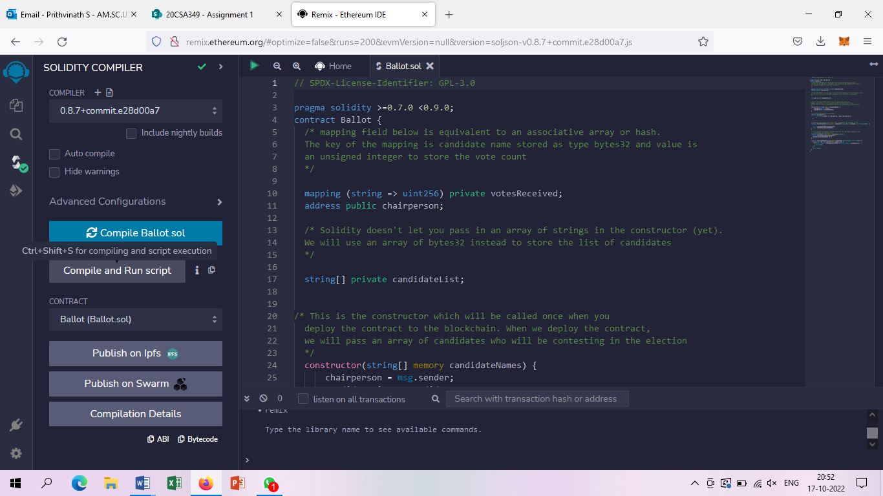

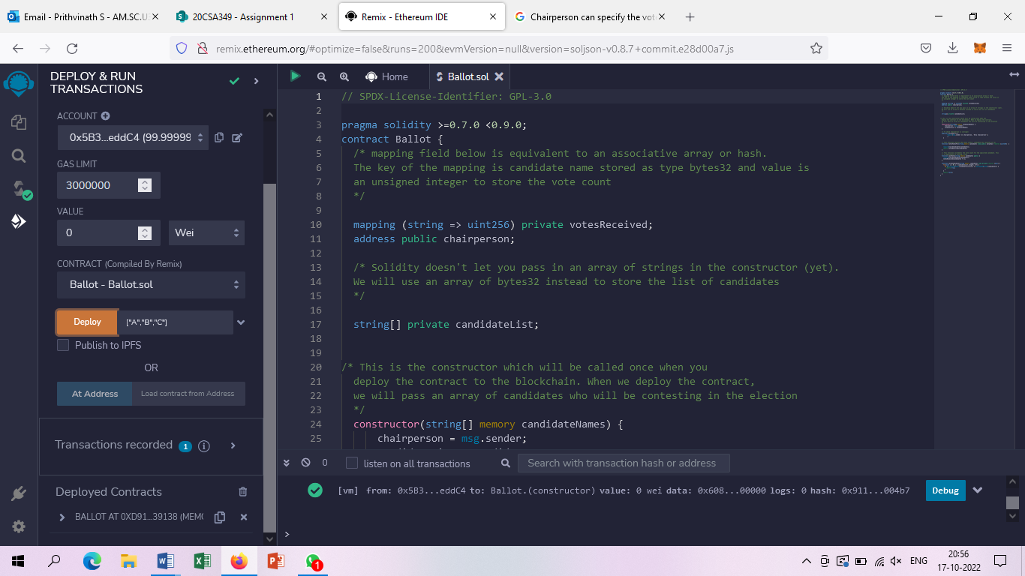

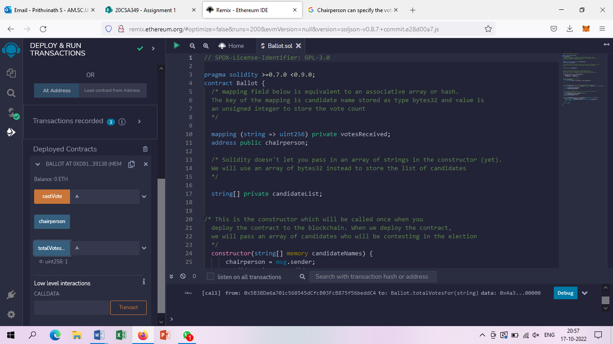

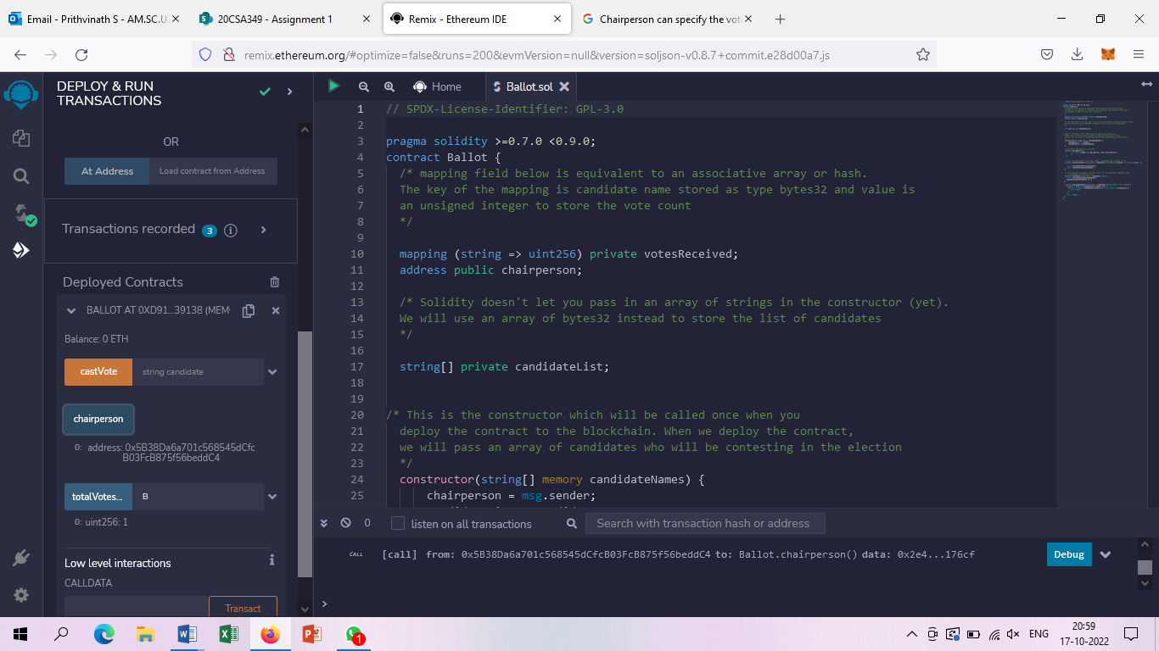

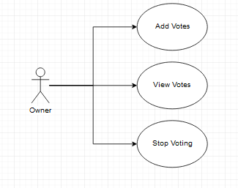

2)

pragma solidity ^0.4.19;

contract constructor {

address owner;    // current owner of the contract

    function TipJar() public{

        owner = msg.sender;

    }

function withdraw() public {

        require(owner == msg.sender);

        msg.sender.transfer(address(this).balance);

    }

    function deposit(uint256 amount) public payable {

        require(msg.value == amount);

    }

    function getBalance() public view returns (uint256) {

        return address(this).balance;

    }

}

pragma solidity ^0.4.19;

contract Bank {

    mapping(address => uint256) public balanceOf;   // balances, indexed by

addresses

    function deposit(uint256 amount) public payable {

        require(msg.value == amount);

        balanceOf[msg.sender] += amount;     // adjust the account's balance

    }

}

